DS Top Up training and EFAW

Joining Instructions

Dear Candidate,

ILM Associates LTD are delighted that you have chosen our company to provide you with your SIA Door Supervisor top up training course.

We have attached some joining instructions with the details for your training, and some mandatory identification requirements/documents that you will need to bring on day one of the course. Unfortunately, if you **DO NOT** bring the required documents and a recent passport photo with you on day one of the course then you will not be allowed to participate in this training so please read the two links below carefully.

**Identity Document list**

<https://www.gov.uk/guidance/apply-for-an-sia-licence#check-you-have-the-right-document>

**Course Dates**

Monday - EFAW - 0900 - 1700

Tuesday, Wednesday, Thursday, Friday, Monday, Tuesday - DS course - 0900 - 1730

**Course Location**

Learning Concepts

Unit 4

Bridge House

Sunderland

SR1 1TE

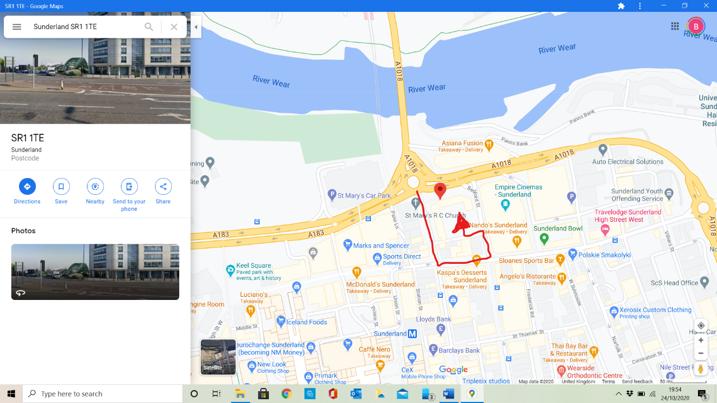

**Dress**

Comfortable clothing should be worn to perform practical tasks.

**Safety**

All learners will have their temperature checked every morning and must use the hand sanitising station at regular intervals throughout the day.

During the course learners will be required to conduct practical close contact training which will involve physical contact. Learners will be provided with safety gloves when required.

**Parking**

There is parking on site which is first come first served basis as the car park services the other business units on site the barrier code is **6497.**

**Please could you confirm your attendance on the course by contacting me via the details below, and if you have any questions about your course, please do not hesitate to contact me.**

Kind regards,

Brian Dawson

Managing Director

ILM Associates LTD

Mob: 07510925318

Land Line: 01915654797