Security Officer Top up

Emergency First Aid at Work

Joining Instructions

Dear Candidate,

ILM Associates LTD are delighted that you have chosen our company to provide you with your security officer top up course.

We have attached some joining instructions with the details for your training, and some mandatory identification requirements/documents that you will need to bring on day one of the course. Unfortunately, if you **DO NOT** bring the required documents with you on day one of the course then you will not be allowed to participate in this training so, please read the two links below carefully.

**Identity Document list**

We ask that you bring the following:

* One Type A: i.e. Passport, Driving Licence
* Two type B: i.e. Utility bill, Bank Statement

For more information or more options on what ID would be suitable, please follow the link below.

<https://www.gov.uk/guidance/apply-for-an-sia-licence#check-you-have-the-right-document>

**Course Start Date & Time**

EFAW – Saturday 09:00 – 16;00 approx

Security Officer Top Up – Sunday 09:00 – 1600 approx

**Course Location**

Unit 2, Bridge House

Sunderland

SR1 1TE

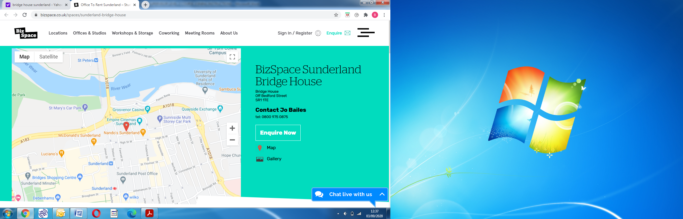

**Dress Code**

Comfortable clothing should be worn to perform practical tasks.

**Safety**

All learners will have their temperature checked every morning and must use the hand sanitising station at regular intervals throughout the day. Please bring your face mask unless you are exempt.

During the course learners will be required to conduct practical close contact training which will involve physical contact. Learners will be provided with safety gloves when required.

**Parking**

We have onsite parking available free of charge on a first come first served basis, the access code for the barrier is **6497. If you require the parking facilities you MUST email over your registration so we can add you to our parking list.**

**Please could you confirm your attendance to the email address below, and if you have any questions, please do not hesitate to contact us.**

[**info@ilmassociates.com**](mailto:info@ilmassociates.com)

Kind regards,



Brian Dawson

Managing Director

ILM Associates Ltd

Mob: 07510 925318

Landline: 0191 565 4797